**Final Year Project**

****

**Smart Surveillance System (SSS)   
Defense Proposal**

**FYP Team**

**Mr. Abdullah Basit | 20I-0623**

**Mr. Abubakar Siddique | 20F-0101**

**Ms. Areeba Rasheed | 19F-0238**

**Supervised by**

**Ch. Usman Ghous**

**Department of Computer Science**

**National University of Computer and Emerging Science**

**Chiniot – Faisalabad Campus, Pakistan**

**2024**

**Anti-Plagiarism Declaration**

This is to declare that the above publication produced under the:

**Title: Smart Surveillance System (SSS)**

is the sole contribution of the author(s) and no part hereof has been reproduced on **as it is** basis (cut and paste) which can be considered as **Plagiarism.** All referenced parts have been used to argue the idea and have been cited properly. I/We will be responsible and liable for any consequence if violation of this declaration is determined.

Date: 14/02/24

Student 1

****Name: Abdullah Basit

Signature: \_\_\_\_\_\_\_\_\_\_\_\_\_\_\_\_\_\_\_

Student 2

Name: Abubakar Siddique

Signature: \_\_\_\_\_\_\_\_\_\_\_\_\_\_\_\_\_\_\_

Student 3

Name: Areeba Rasheed

Signature: \_\_\_\_\_\_\_\_\_\_\_\_\_\_\_\_\_\_\_

**Abstract**

This project proposal outlines the development of an advanced surveillance system for universities, integrating facial recognition, behavior analysis, and real-time data analytics to address safety and ethical issues. By detecting smoking, fighting, and littering, the system aims to enhance campus security and promote a safer environment. Employing machine learning and computer vision technologies, the project leverages Python, PostgreSQL, and TensorFlow among other tools, to create a comprehensive solution that surpasses traditional CCTV limitations. This innovative approach ensures precise individual tracking and efficient anomaly detection, setting a new standard for surveillance technology in educational institutions.

Table of Contents

[1. Vision Document 1](#_Toc159448264)

[1.1. Introduction 1](#_Toc159448265)

[1.1.1. Problem Statement 1](#_Toc159448266)

[1.1.2. Objectives 1](#_Toc159448267)

[1.2. Motivation 2](#_Toc159448268)

[1.3. Overview 2](#_Toc159448269)

[1.4. Functionality 2](#_Toc159448270)

[1.4.1. Facial Recognition Module 2](#_Toc159448271)

[1.4.2. Smoking Behavior Detection Module 3](#_Toc159448272)

[1.4.3. Fighting Behavior Detection Module 3](#_Toc159448273)

[1.4.4. Littering Behavior Detection Module 3](#_Toc159448274)

[1.4.5. Time and Location Logging Module 3](#_Toc159448275)

[1.4.6. Data Management, Reporting, and Alert Module 4](#_Toc159448276)

[2. Tools and Technologies 4](#_Toc159448277)

[2.1. Python 4](#_Toc159448278)

[2.2. PostgreSQL 4](#_Toc159448279)

[2.3. Visual Code 4](#_Toc159448280)

[2.4. Postman 4](#_Toc159448281)

[2.5. Node.js 5](#_Toc159448282)

[2.6. React 5](#_Toc159448283)

[2.7. Jupyter 5](#_Toc159448284)

[2.8. TensorFlow 5](#_Toc159448285)

[2.9. Git/Github 6](#_Toc159448286)

[3. Required hardware and Software resources 6](#_Toc159448287)

[3.1. Hardware 6](#_Toc159448288)

[3.2. Software 6](#_Toc159448289)

[4. High Level Diagram 7](#_Toc159448290)

[5. Timeline 7](#_Toc159448291)

[6. Constraints 8](#_Toc159448292)

[7. References 9](#_Toc159448293)

# Vision Document

This vision document lays the foundation for a transformative surveillance solution, paving the way for a detailed exploration of its necessity and framework.

## Introduction

Delving deeper, we identify the core challenges that our innovative surveillance system seeks to address, spotlighting the pressing need for smart surveillance system within academic environments.

### Problem Statement

In today's security and surveillance environments, such as universities, the existing CCTV systems lack the sophistication to track, identify, and analyze individual activities in real-time. This gap in technology results in significant challenges in ensuring the safety, security, and ethical issues within universities. Our project aims to develop a comprehensive system that integrates facial recognition, smoking, fighting, and littering detection, location tracking, time analysis, data management, and an alert notification system. By harnessing machine learning algorithms and real-time data analytics alongside computer vision models, our system will provide precise individual tracking and anomaly detection for smoking, fighting, and littering. The project addresses the critical need for an advanced surveillance system that can adapt to the dynamic nature of human activities within universities that are raising ethical issues.

### Objectives

* **Enhanced Surveillance Solution:** Develop an advanced surveillance system tailored for high-security environments, employing individual ID tracking to optimize operational efficiency.
* **Refined Behavior Analysis:** Implement an integrated surveillance solution to detect and address specific behavioral violations on campus, including smoking, littering, and fighting. Utilize advanced machine learning and computer vision technologies for real-time identification and analysis of these activities. This system aims to enforce university policies on smoking and littering while promoting a safe environment.
* **Reliable Monitoring System:** Establish a foolproof monitoring solution that eliminates common human oversights, such as misidentification or lapses in vigilance.
* **Safe Campus Environment:** Establish a safe campus environment for students and faculty likewise that ensures a safe, clean, smoke free zone that penalizes the violators of fighting, littering and smoking.
* **Immediate Alert Mechanism:** Introduce a rapid alert and notification system to enable swift responses in critical situations, such as fighting, where timely intervention is crucial.

## Motivation

Our project is motivated by the pressing need to address ethical concerns within educational institutions, focusing on preventing smoking, littering, and fighting in universities. Leveraging the latest in facial recognition, machine learning, and behavior analysis, we aim to bridge the gap in real-time surveillance accuracy. This innovation promises a smarter, safer, and more efficient monitoring system.

## Overview

We propose an advanced surveillance system, combining facial recognition, activity and location tracking, and behavior analysis related to smoking, littering, and fighting to prevent these ethical issues in universities. Incorporating machine learning for detection, alongside a robust data management and alert system, our project aims to surpass traditional CCTV limitations. This integrated approach ensures a safer, more controlled environment, setting a new standard for prevention of above discussed behaviors raising ethical issues in surveillance technology focused towards universities in Pakistan.

## Functionality

SSS is an advanced system that encompasses a wide range of modules that will cover the scope of our project.

### Facial Recognition Module

Individuals will be recognized through facial recognition technology for real-time identification within the surveillance area. SSS captures facial features from video feeds and matches them against a per-maintained database of facial ID’s to identify persons of interest. Once identified, each person is assigned a unique ID i.e. their roll number, which will enable the system to track their movements across different camera feeds. This technology is core for ensuring that individuals can be accurately monitored in real time. For the effective implementation of this module, Student RFID Dataset and CCTV recordings of our university have been requested from campus administration.

### Smoking Behavior Detection Module

Detect instances of smoking within the university to ensure the implementation of facility policies and health regulations. This module utilizes the HMDB: a large human motion database’s dataset on smoking [2] and our facial recognition module to identify the individual involved in the violation of smoking. Utilize the machine learning model trained on the datasets of smoking specifically cigarettes. Through computer vision detecting the individual’s face which will be matched with records in database.

### Fighting Behavior Detection Module

Identify physical fights to maintain safety, and security with in facility. The module analyzes body movements, and proximity between the individuals to detect the potential fights, assigning weights based on the intensity. It will detect the individual faces involved in the fight through facial recognition. Depending on a certain threshold of the weighted incidents, an alert will be generated to the local security administrator via the dashboard. The dataset consists of Vision-based Fight Detection from Surveillance Cameras that are uploaded on YouTube (Dataset available on GitHub [5]).

### Littering Behavior Detection Module

Detect littering within the facility to ensure a hygienic environment. This module detects a person throwing litter using pose estimation, detected based on his/her dumping action and then identifying them using our facial recognition module. Currently, no publicly available dumping action detection datasets are available, though we have found a paper “Anti-Litter Surveillance based on Person Understanding via Multi-Task Learning” [6] and have requested them for their self-created dataset.

### Time and Location Logging Module

Utilizing the data from live camera feeds, this module allows the real-time tracking of individual’s movements within the facility, aiding in maintaining the individuals whereabouts (based on camera name) whenever an alert is generated. Simultaneously, a timestamp is logged as proof so that the recording from the database is easily retrieved when it is needed.

### Data Management, Reporting, and Alert Module

A database stores tracked data, including timestamps of individuals’ locations and activities whenever alerts are generated. The module generates reports and analytic that can be used for detection of individuals, and insights into the overall happenings related to smoking, fighting and littering in the facility.

# Tools and Technologies

Our system would comprise of multiple components ranging from front-end to back-end and a database as well. Similarly, Machine Learning and Computer Vision are also a core part of our project. Thus, we would need a diverse set of tools for our project.

## Python

For smart surveillance system with Python, use Open-CV for processing video frames. Implement object detection with per-trained models like YOLO. By combining Python's versatility, Open-CV, and per-trained models like YOLO the system excels in tracking in video streams.

## IMG_256 PostgreSQL

PostgreSQL, being relational, ensures data integrity and complex query support, suitable for scenarios where structured data management and strong consistency are crucial PostgreSQL for structured data and strong consistency, ideal when data integrity and complex queries matter.

## IMG_256 Visual Code

Visual Studio Code, the chosen IDE, offers a user-friendly interface with robust Python support for efficient coding, debugging, and version control. Its built-in extensions and rich ecosystem streamline development, enhancing productivity in implementing vision-based algorithms and integrating machine learning models for seamless compatibility with Python libraries in surveillance applications.

## IMG_256 Postman

Postman is used in the smart surveillance system for testing and managing APIs. With a user-friendly interface, it enables developers to create, share, and execute API requests, ensuring seamless communication between system components.

## IMG_256 Node.js

Express.js, a fast, opinionated, minimalist web framework for Node.js, will serve as the backbone of the SSS back-end. This setup is ideal for handling the real-time data processing demands of SSS due to its lightweight nature and efficient handling of asynchronous requests.

## React

React, a declarative, efficient, and flexible JavaScript library for building user interfaces, will be employed to develop the front-end of the Smart Surveillance System (SSS). Its component-based architecture enables the creation of dynamic and interactive web applications with minimal coding. React's state management facilitates seamless data flow and real-time updates to the UI, enhancing the user experience for system administrators and security personnel.

## Jupyter

Jupyter Notebooks, an open-source web application, will be used for developing and executing machine learning models and data analysis tasks. It allows for the creation of documents that include live code, equations, visualizations, and narrative text. By integrating Jupyter, our project leverages a platform for iterative development and collaboration, enabling us to fine-tune algorithms and share insights efficiently.

## TensorFlow

TensorFlow, an open-source machine learning framework, will be pivotal for developing and deploying advanced machine learning models within the SSS. It offers a comprehensive ecosystem of tools, libraries, and community resources that enable researchers to push the state-of-the-art in ML, and developers to easily build and deploy ML-powered applications. TensorFlow's flexibility and scalability will be harnessed to design, train, and implement models capable of real-time behavior analysis, facial recognition, and anomaly detection.

## Git/GithubC:\Users\alpha\AppData\Local\Microsoft\Windows\INetCache\Content.Word\git.png

Git, a distributed version control system, along with GitHub, an online platform for code hosting and collaboration, will serve as the backbone for version control and source code management in the project. This integration ensures that the development process is streamlined, changes are tracked systematically, and the entire project team can easily collaborate, review progress, and integrate their work into a unified codebase.

# Required hardware and Software resources

## Hardware

Following hardware is required to develop this project

|  |  |
| --- | --- |
| Hardware | Specifications |
| Development PC / Laptop | * 8 GB RAM minimum * Core i5 5th Gen (4 cores) minimum * 2 GB GPU minimum |
| External HDD | * 500 GB Minimum |
| Monitoring System 2nd Screen | * 1080p minimum |

Table 1. Hardware Requirements

## Software

Following software's are required for the development of this project

|  |  |
| --- | --- |
| Software | Purpose |
| Python | Programming Language |
| Visual Studio Code | IDE |
| Postman | Managing API’s |
| Node.js | Back-end of Web Application |
| React | Front-end User Interface Development |
| PostgreSQL | Database Management |
| TensorFlow | Machine Learning Framework |
| Git/GitHub | Version Control and Collaboration |
| Jupyter | Data Analysis and ML Model Prototyping |

Table 2. Software Requirements

# High Level Diagram

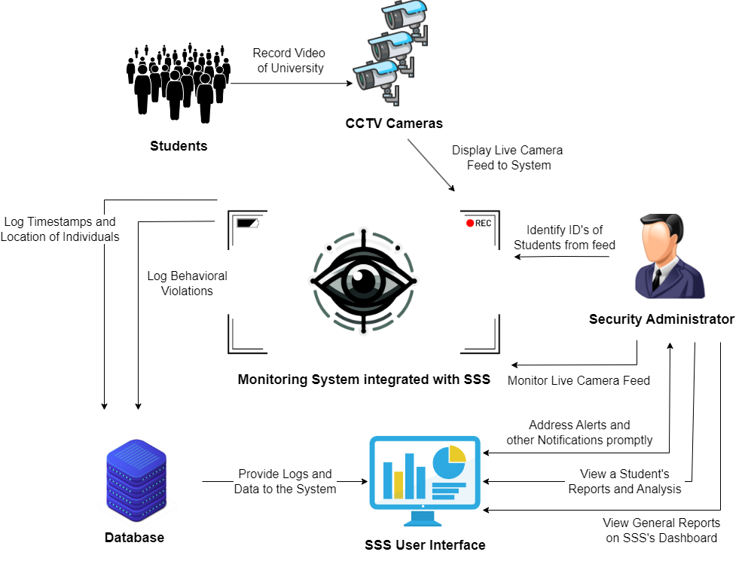

Fig 1. High Level Diagram of SSS

# Timeline

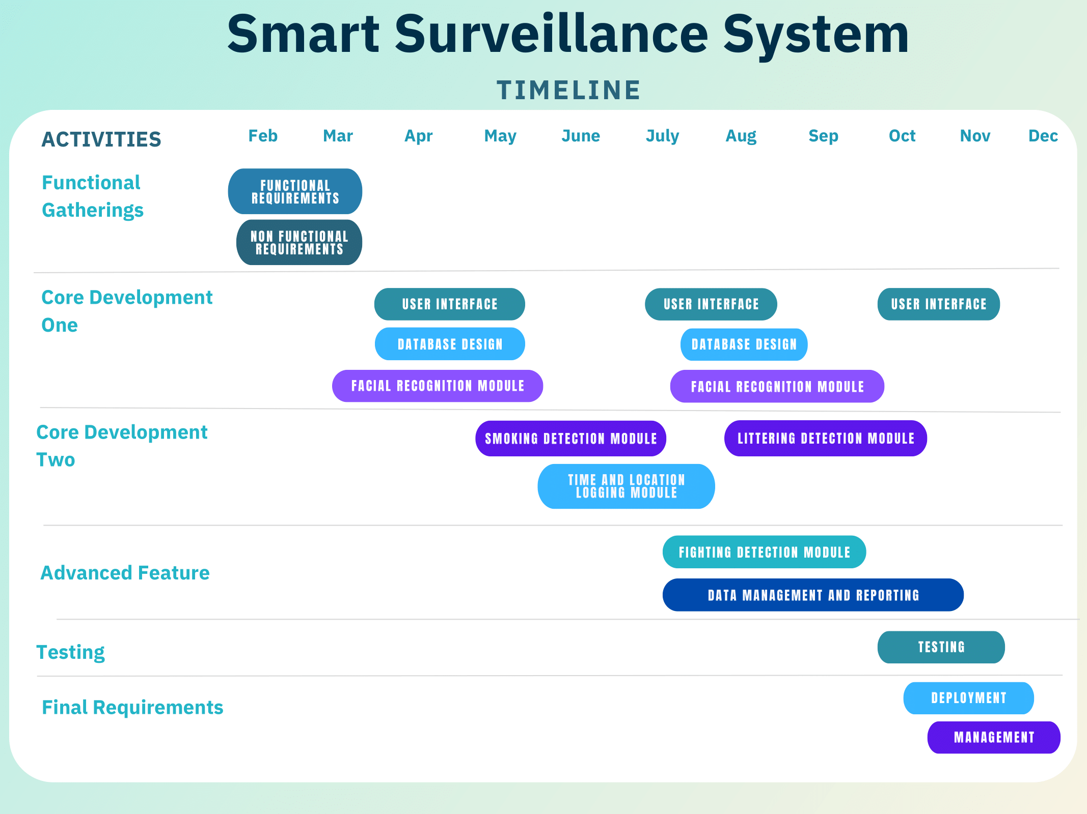

Fig 2. Gantt chart of SSS

# Constraints

* Our surveillance system requires the use of high-quality cameras with at least 720p resolution. This is necessary to ensure the images are clear enough for our system to accurately recognize faces and detect specific behaviors.
* The development of our littering detection module depends on obtaining a specific dataset from the authors of a relevant study [6], as outlined in section 1.4.4. This module's implementation is conditional upon this collaboration, highlighting the need for access to unique data for effectively identifying and addressing littering incidents within our surveillance framework.

# References

1. A. Lee, "What is China’s social credit system and why is it controversial?" South China Morning Post, 09 Aug. 2020. [Online]. Available: <https://www.scmp.com/economy/china-economy/article/3096090/what-chinas-social-credit-system-and-why-it-controversial>.
2. H. Kuehne, H. Jhuang, E. Garrote, T. Poggio, and T. Serre, "HMDB: A Large Video Database for Human Motion Recognition," in ICCV, 2011. [Online]. Available: https://serre-lab.clps.brown.edu/resource/hmdb-a-large-human-motion-database/.
3. K. Dhanalakshmi Srivani, "YOLO Algorithm for Custom Object Detection," Analytics Vidhya, 30 Oct. 2023. [Online]. Available: <https://www.analyticsvidhya.com/blog/2022/06/yolo-algorithm-for-custom-object-detection>.
4. Correspondent, "Bikers sans helmet to receive e-challan," The Express Tribune, 26 Jan. 2024. [Online]. Available: <https://tribune.com.pk/story/2454420/bikers-sans-helmet-to-receive-e-challan>.
5. S. Akti, "New generated dataset for fight detection in surveillance cameras," GitHub repository, 2023. [Online]. Available: <https://github.com/seymanurakti/fight-detection-surv-dataset>.
6. K. Bae, K. Yun, H. Kim, Y. Lee, and J. Park, "Anti-Litter Surveillance based on Person Understanding via Multi-Task Learning," in Proceedings of the British Machine Vision Conference (BMVC), 2020. [Online]. Available: https://www.bmvc2020-conference.com/assets/papers/0279.pdf.